**User Management stuff from SD side**

Our customer SD wants direct Login for the operator user, If we want to switch the user he/she has to logout and get back the login screen for service user because the service user also login with credentials, the service user can allow to add another service and operator user and he/she can able to update the password for those users, but the operator does not allow to do that.

If we have one or more operator then we should do the login first, we should not give a possibility to access the user administration stuffs to the operator level.

**NOTE:** Our customer SD didn’t have an Expert user level.

**Current Situation**

Direct login is already working with current set up if we have only one user and that too he/she has an operator user, otherwise display the login screen.

**What we need to do?**

We need to adjust the Auto Login feature which needs to fit our customer requirements.

Need a configuration setup for enable/disable this feature, because we are not sure other customer would also expect the same?

**Adjust the Personal Settings View**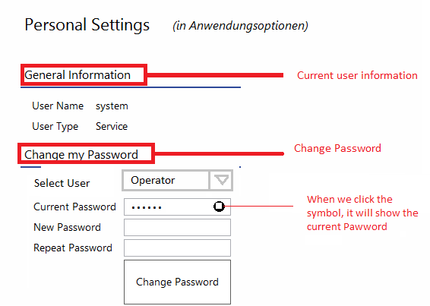

**Adjust Person Settings View Model**

* Implement the feature visibility, because we should allow changing the other’s password by service user not for the operator.
* Implement the password string visibility (hash coded password to original password).

**Adjust the Logout function**

Currently it’s simply logout the current user and displays the login screen.

To Do:

* Check the current user, if he/she is an operator, and then switch to service user and vice versa.
* If we switch to service, ask the login credentials.
* If we switch to operator, check if we have multiple operators then ask credentials, otherwise direct login option enable.

**Adjust the Auto Login function**

Currently its do the auto login when we have a single user and that too it has an operator user.

To Do:

* Do auto login if we have only one operator but we have other type operators.
* Keep the previous state.
* Need a configuration switch like “IsOperatorAllowToDirectLogin” or something the use this switch in the Auto login feature.

**Things to Check**

**IMPORTANT:** Please check the system also with Air-Conditioned room UI.**Operator**

* If only one operator in the database i.e. we can have other type of user, Do the direct login.
* If multiple operators, Do the Login first.
* Should not allow the admin stuff.
* Should allow to change the own password not for other’s
* Should not allow changing the other type of user’s password.
* If we have only one operator i.e. we don’t have any other type of user, do not allow switching user.
* If we have more users, then allow to switching the user.

**Service**

* Allow to do the administration stuff.
* Allow to change the password for other type of user’s
* Ask the credentials while switching.